H.T No
Regulations:
A20

Sreenidhi Institute of Science and Technology
(An Autonomous Institution)
Code No: 8HC09 Date: 18-Mar-2023 (AN)

B.Tech I-Year I- Semester External Examination, March/April-2023 (Supplementary)
MATRIX METHODS AND CALCULUS (CIVIL, EEE, ME and ECE)

Time: 3 Hours Max.Marks:70

Note: a) No additional answer sheets will be provided.
b) All sub-parts of a question must be answered at one place only, otherwise it will not be valued.
c) Missing data can be assumed suitably.
Bloom's Cognitive Levels of Learning (BCLL)

Remember | L1 | Apply | L3 | Evaluate | L5
Understand | L2 | Analyze | L4 | Create | L6

Part - A Max.Marks:20

Answer all QUESTIONS.

 |  | BCLL | CO(s) | Marks
1 | Define rank of a matrix. | L1 | CO1 | [2M]
2 | Define Eigen value of a matrix. | L1 | CO2 | [2M]
3 | Define half range sine series. | L1 | CO3 | [2M]
4 | State Rolle’s theorem. | L2 | CO4 | [2M]
5 | Define Beta function. | L1 | CO5 | [2M]
6 | Define Gradient of scalar point function. | L1 | CO6 | [2M]
7 | Evaluate the rank of 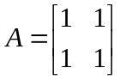 | L5 | CO1 | [2M]
8 | Define sequence. | L1 | CO3 | [2M]
9 | Evaluate curl(grad) | L5 | CO6 | [2M]
10 | Define Hermitian matrix. | L1 | CO2 | [2M]

Part – B Max.Marks:50
ANSWER ANY FIVE QUESTIONS. EACH QUESTION CARRIES 10 MARKS.

 |  |  | BCLL | CO(s) | Marks
11. | a) | Reduce the matrix 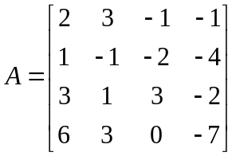 into Echelon form and find it’s rank. | L5 | CO1 | [5M]
 | b) | Evaluate the system of equations by Gauss elimination method: | L3 | CO1 | [5M]
12. |  | Determine the Eigen values and Eigen vectors of the matrix 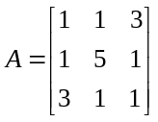 | L5 | CO2 | [10M]
13. |  | If 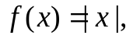 expand 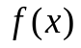 as a Fourier series in the interval 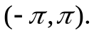 | L5 | CO3 | [10M]
14. | a) | Verify Rolle’s theorem for the function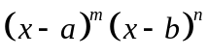 in 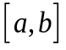, 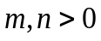 | L3 | CO4 | [5M]
 | b) | Using Maclaurin’s series expansion expand the function 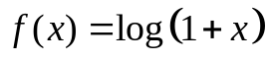 | L5 | CO4 | [5M]
15. | a) | Show that 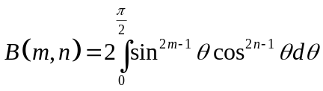 | L5 | CO5 | [5M]
 | b) | Find the volume of the portion of the sphere 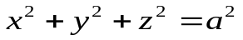lying inside the cylinder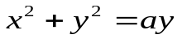. | L5 | CO5 | [5M]
16. | a) | If 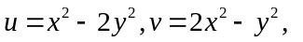where 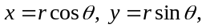 show that 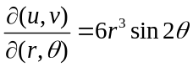 | L5 | CO6 | [5M]
 | b) | Evaluate 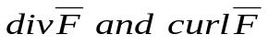at the point (1, 2, 3) given 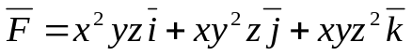 | L5 | CO6 | [5M]
17. | a) | Find rank of 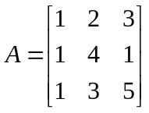 using echelon form. | L5 | CO1 | [4M]
 | b) | Using Cayley-Hamilton theorem find the inverse of the matrix 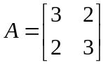 | L3 | CO2 | [3M]
 | c) | Test for the convergence of the series 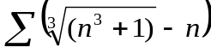 | L3 | CO3 | [3M]
18. | a) | Verify Lagrange’s mean value theorem for 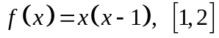 | L3 | CO4 | [4M]
 | b) | Show that 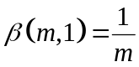 | L5 | CO5 | [3M]
 | c) | Find the gradient of 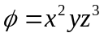 | L5 | CO6 | [3M]

-- 00 -- 00 –

